The Cross Keys

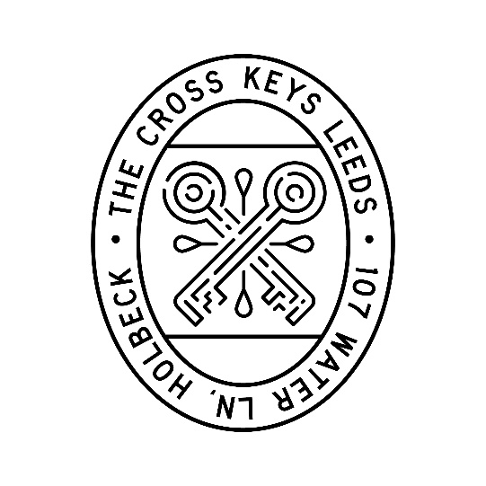

Snacks
Olives (VE) £4.00
Rosemary focaccia, balsamic and oil (VE) £5.00
Smoked almonds (VE) £3.50
A selection of all 3 snacks £10.00

Small Plates
Korean wings, crispy onion, sesame seeds, coriander £8.50
Calamari, wasabi mayo, lemon £8.00
Butterflied garlic butter prawns £8.00

Sunday Roasts
All of our Sunday Roasts are served with roast potatoes, seasonal spring greens,
cauliflower cheese, roasted carrot, red wine gravy and a Yorkshire pudding.

Roasted Lamb Rump £23.00
Treacle Cured Beef £22.00
Whole Roasted Poussin £22.00
Vegetarian Chicken £21.00
(Also available Vegan, served without yorkies and cauliflower cheese)

Additional sides
Roast potatoes £5.00
Spring greens £4.50
Side salad £4.50

Desserts
Sticky Toffee Pudding, rich toffee sauce, clotted cream vanilla ice cream £8.50
Praline chocolate brownie, clotted cream vanilla ice cream or vegan whipped cream (GF) (VE) £8.00
Clotted cream vanilla ice cream (3 scoops) £5

What we’re drinking…
Roasted Lamb Rump - Pinot Noir, Calusari £28.00
Treacle Cured Beef - Merlot, Nostros Gran Reserva £33.50
Whole Roasted Poussin – Piquepoul Terret, Pique & Mixe £31.00
Vegetarian Chicken - Verdejo Orgánico, Campo Flores £26.50

