The Cross Keys

Snacks
Olives (VE) £4.00
Rosemary focaccia, balsamic and oil (VE) £5.00
Smoked almonds (VE) £3.50
A selection of all 3 snacks £10.00

Small Plates
Korean wings, crispy onion, sesame seeds, coriander £8.50
Calamari, wasabi mayo, lemon £8.00
Butterflied garlic butter prawns £8.00

Mains
Cumberland sausage with parmesan truffle mash, red wine jus and parsley £17.00
Panko coated chicken thigh, rice, katsu curry sauce, tenderstem broccoli £17.00
Fish & chips, pea puree, tartare sauce, chunky chips £17.50
California salad, dressed quinoa, roasted root vegetables, tenderstem broccoli, mixed leaves, rocket,
avocado cream and sesame seeds (VE) £15.00

Burgers
Cross Keys burger, double patty, smoked bacon, pickles, rocket, red onion chutney, house sauce,
American cheese, seeded bun, chunky chips £17.50
Vegan burger, moving mountains meat patty, vegan cheese, pickles, rocket, house sauce, red onion
chutney, crispy onion, brioche style bun, chunky chips (VE) £17.50

Sides
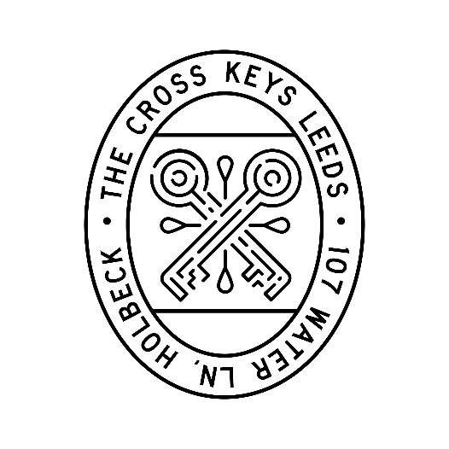
Chunky chips £4.50
Skinny fries £4.50
Add truffle & parmesan for £1.50
Tenderstem broccoli £4.50
Green salad £4.50

Desserts
Sticky toffee pudding, rich toffee sauce, vanilla ice cream £8.50
Triple chocolate brownie, pistachio sauce, vanilla ice cream £8.00
Vanilla ice cream (3 scoops) £5.00
Add pistachio sauce for £1.00

